To Members of Governance & Scrutiny Committee
Dear Councillor and Committee Member

I summon all members to attend a meeting of the Governance & Scrutiny Committee to be held on Tuesday 18th March 2025, 11am at Silkencrest, High Street, Bream, GL15 6JF (this is Cllr Francis home address as we are meeting here due to her recent operation)
Yours sincerely
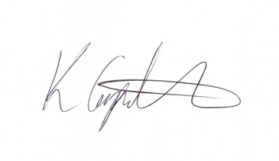
Kim Carpenter
Clerk
 | Governance & Scrutiny Committee
1 | Apologies  To receive any apologies
2 | Declaration of Interest  To receive any declarations of interest
3 | Minutes of the last meeting  To agree the minutes of the meeting held on 21st January 2025
4 | Scrutiny & Review of Council Policies & Procedures  To review and approve the following policies for Full Council resolution at the January Parish Council Meeting:  - Member Absence & Apologies Policy  - Capability Procedure
5 | Internal Audit  To discuss the GAPTC internal audit process, including feedback from experience of service and make a recommendation to Council for the 2026 internal audit.
6 | West Dean Centre  To discuss the motion presented to the West Dean Centre Management Committee which recommends the following:  - The WDC Management Committee is disbanded in its existing form  - The estate management and finances are taken over by WDPC  - A new committee is formed that is a focus and advisory group of users and councillors, whose plans, ideas etc would be reported to Council for approval.  - The financial management would become part of the Finance Committee’s remit and part of WDPC normal financial arrangements.  - Rental costs will be maintained at affordable rates for hirers of the facility.  - The daily running would still be part of the Deputy Clerks post, supported by the committee. (need to clarify how much time this takes within the post!)  - None of these recommendations would preclude WDPC further investigating the transfer of the centre to a Trust or similar in the future.
7 | Date of the Next Meeting  The next meeting is scheduled for Tuesday 20th May 2025 at 11:30am in the West Dean Centre.

Due to the Clerking situation there is a proposal for short term management of Council which should be discussed by Staffing Committee and it would be appreciated if those attending the Governance Committee could stay on to consider this idea for presentation to Council.

