To Members of Governance & Scrutiny Committee
Dear Councillor and Committee Member

I summon all members to attend a meeting of the Governance & Scrutiny Committee to be held on Tuesday 21st January 2025 at Silkencrest, High Street, Bream, GL15 6JF (this is Cllr Francis home address as we are meeting here due to her recent operation)
Yours sincerely
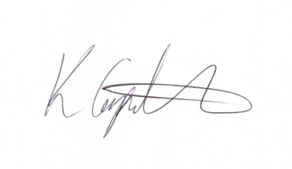
Kim Carpenter
Clerk
 | Governance & Scrutiny Committee
1 | Apologies  To receive any apologies
2 | Declaration of Interest  To receive any declarations of interest
3 | Minutes of the last meeting  To agree the minutes of the meeting held on 17th September 2024
4 | Scrutiny & Review of Council Policies & Procedures  To review and approve the following policies for Full Council resolution at the January Parish Council Meeting:  - WDPC General and Earmarked Reserves Policy  - WDPC Anti-fraud and Corruption Policy  - WDPC Investment Policy
5 | Government Consultation: Strengthening The Standards and Conduct Framework for Local Authorities England  The Government is seeking views on proposals to introduce measures to strengthen the standards and conduct regime for local authorities in England. The proposals being consulted upon include:  - The introduction of a mandatory minimum code of conduct  - All principal authorities convene formal standards committees to make decisions on breaches and publish outcomes of formal investigations  - Power to all local authorities to suspend councillors of mayors found in serious breach of the code of conduct and as appropriate, interim suspension for the most serious and complex cases that may involve police investigations  - A new category of disqualification for gross misconduct and those subject to a sanction of suspension more than once in a 5-year period  - A role for a national body to deal with appeals.  To discuss and formulate an appropriate response to this consultation, if deemed necessary, on behalf of West Dean PC for submission by 26th February 2025.
6 | Email Acceptable Use Policy – Appendix  To discuss and decided on the type and sources of information to assist Council in protecting their own IT equipment to comply with this policy and develop the appendix for inclusion with the policy document:  - Antivirus protection – malicious software and viruses  - Email signature  - Top tips for staying secure online - NCSC.GOV.UK
7 | Transparency  To discuss a change to the website to include a transparency page that provides greater detail to residents of The Local Government Transparency Code 2015 and its requirements.  Example from Weymouth Town Council Transparency - Weymouth Town Council | Weymouth Town Council
8 | Date of the Next Meeting  The next meeting is scheduled for Tuesday 18th March 2025 at 11am in the West Dean Centre.

