To Members of Finance Committee

Dear Councillor and Committee Member
I summon all members to attend a meeting of the Finance Committee to be held on Wednesday 16th October 2024 at 10:00am in the Witherby Room of the West Dean Centre.

Yours sincerely
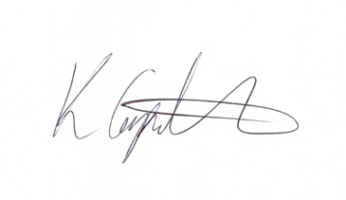
Kim Carpenter
Clerk
 | Finance Committee
1 | Apologies  To receive any apologies for absence.
2 | Declaration of Interest  To receive any declarations of interest from Councillor’s.
3 | Minutes of the last meeting  To review and approve the minutes of the previous meeting.
4 | Council Tax Support Consultation  To agree the feedback for submission to the Forest of Dean District Council on their Council Tax support consultation documents and the two options proposed.  Appendix 1 - consultation document.
5 | Active Travel Grant Application Support  To discuss the match funding required for this grant application, which is 20% with a maximum grant allocation of £15k, and if the reserves held for the multi-use track project can be utilised.
6 | Community Grant Awards  Review of the 15 applications for funding received for the Autumn 2024 Awards and decided the levels of funding to be awarded.  A Dropbox link to the applications was sent to Council for review and is included below:
9 | Date of Next Meeting  To be arranged as necessary.

Appendix 1 = Council Tax Support Consultation document

