To Members of Governance & Scrutiny Committee
Dear Councillor and Committee Member

I summon all members to attend a meeting of the Governance & Scrutiny Committee to be held on Tuesday 16th July17th September 2024 at 11am in the West Dean Centre
Yours sincerely
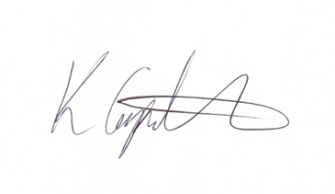
Kim Carpenter
Clerk
 | Governance & Scrutiny Committee
1 | Apologies  To receive any apologies
2 | Declaration of Interest  To receive any declarations of interest
3 | Minutes of the last meeting  To agree the minutes of the meeting held on 16th July 2024
4 | Scrutiny & Review of Council Policies & Procedures  To review and approve the following policies for Full Council resolution at the September Parish Council Meeting:  - Asset Valuation and Register Policy  - Social Media Policy  - Update to Acceptable Email Usage Policy?
5 | Date of the Next Meeting  The next meeting is scheduled for Tuesday 19th November 2024 at 11am.

