
To, Members of West Dean Parish Council
WEST DEAN PARISH COUNCIL

Kim Carpenter Phil Holland
Proper Officer Deputy Clerk
Tel. Parish Office: 01594 564484 (9.00am – 4.00pm)
Email: clerk@westdeanpc.org.uk
Web site: www.westdeanpc.org.uk

Parish Office
West Dean Centre
High Street
Bream
Glos.
GL15 6JW

PARISH COUNCIL AGENDA

Dear Councillor Date issued: 22nd August 2024

I summon all members to attend the West Dean Parish Council meeting to be held on Wednesday 28th August 2024 at 7pm in the West Dean Centre for the purpose of transacting the business on the agenda as set out below.

Members are reminded that the Council has a general duty to consider the following matters in the exercise of any of its functions: Equal Opportunities, Crime & Disorder, Health & Safety and Human Rights plus Social, Economic and Environmental matters.

The Council Meeting will follow the Public Forum, which will begin at 7.00pm.

Please note change of location to the West Dean Centre for 28th August 2024 meeting.

Yours sincerely
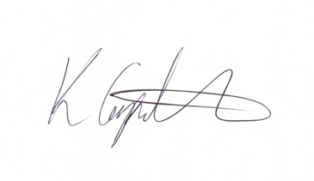
Kim Carpenter
Parish Clerk/RFO

PUBLIC QUESTIONS & COMMENTS – 7.00 pm to 7.30 pm

24081 | Council Formal Business
24081.1 | Co-option of Councillor  To receive the application from Rachel Chance to become a parish councillor for the Pillowell Ward.  Attachment - Application form for the role of parish councillor completed by Rachel Chance in Councillor Agenda Pack (confidential under 32. Sensitive Interests (b) as checked with the Monitoring Officer at FoDDC).
24081.2 | Apologies  To receive, and consider for approval, any apologies for absence and reasons given.
24081.3 | Declarations of Interest  To receive any declarations of interest, members are reminded to declare any interest on any item on this agenda at this point or at any point during the meeting in accordance with the Council’s Code of Conduct.  A request for dispensations can be requested at the meeting and the paperwork completed for consideration.
24081.4 | Minutes of the Previous Meeting  To confirm and sign the minutes of the meeting held the 31st July 2024.  Attachment – Minutes of the Council meeting held on 31st July 2024
24082 | Items for Consideration and Resolution
24082.1  24082.1i  24082.1ii  24082.1iii  24082.1iv | Finance and Staffing  To receive and note the budget monitoring information for WDPC and WDC.  Attachments 2.1v – Working Budgets 2022/23 WDPC & WDC & Budget overview documents.  To review and approve the July 2024 expenditure payment schedule, Direct Debits, Standing Orders, and credit card transactions totalling WDPC = £13,029.15 excluding VAT and WDC = £1411.22 excluding VAT. Attachment – 2.1i WDPC Expenditure payment schedule.  To advise Council that Cllrs a Bruce and A Grant are to authorise payments on the banking system for WDPC.  To note that the July financial inspections has not been completed but will be undertaken by Cllrs Yeates and Roberts when the financial inspection of August transactions for WDPC and WDC is undertaken.  To note the Conclusion of Audit and the publication of the certificate which details that the documents are available for residents to view, giving the location and the times available.
24082.2 | Crossing Cottage Footpath, Whitecroft  To receive a verbal report from Cllr Freshwater that proposes the following motion for consideration by Council:  That the PC writes to the owners of Crossing Cottage advising that Land Registry have confirmed that the deeds are associated with the property and that we have also sought advise that confirms that the path should be open at all times. The PC also acknowledges that due to excessive growth the path is now unusable, and that the owner should clear all obstructions.  The PC instructs the Clerk to contact the owner to advise that we require the path to be cleared with 14 working days.
24082.3 | The Forest of Dean Gateway  To approval and agree the Forest of Dean Gateway Planning Application and its appendices, as presented, for submission to the FoDDC Planning Department.  2.3 – Attachments – planning application, the various appendices which supports the planning application. These will also be presented on screen at the Council meeting.
24082.4 | Flooding at Gamekeeper Public House, Five Acres  To receive a verbal report from Cllr B Freshwater regarding the ongoing issues of flooding at this location.
24083 | Items for Information – Councillors to note.
24083.1 | Planning Committee  To receive and note the minutes of the Planning Committee held on 6th and 20th August 2024.  Attachment – Minutes of the Planning Committee meetings held on 6th and 20th August 2024.
24083.2 | Highways & Footpaths Committee  To receive and note the minutes of the Highways & Footpaths Committee held on 20th August 2024.  Attachment – Minutes of the Highways & Footpaths Committee held on 20th August 2024.
24083.3 | Chairs Items  To receive any reports or information from the Chair.  Connections Meeting – Cllr Freshwater and Clerk  CAB update on service delivery
24083.4 | Clerks Reports  To receive a verbal update.  Attachment – Clerks Report
24083.5 | Public Round-up – 10 minutes  A time set aside for any members of the public to comment or ask further questions following the meeting.
24054 | Forthcoming Meeting Schedule:
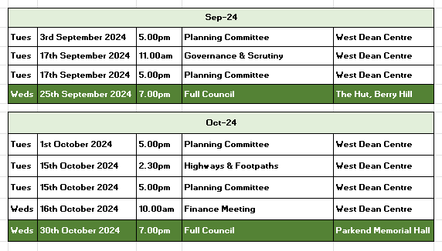
1 The Public Questions & Comments is designed to give electors the opportunity to make representations to the Council or to ask questions. It takes place before the formal meeting of the Council.
2 The time allocated to the whole period of the open forum is 30 minutes.
3 Whether your attendance is part of a deputation or as an individual, the spokesperson will be invited to put the case with a maximum time limit of 10 minutes. Follow up speakers will be allowed 5 minutes in total. Speakers may only speak once.
4 The Chairman will decide whether he/she can advise the deputation immediately or if he needs to sound out members and/or consult the Clerk. The Chair will then inform the deputation what action the Parish Council intends to take.
5 The initial response by the Council will be to establish if the matter is something which the Council should be involved in as a matter of public interest or is a private matter for the electors to deal with themselves.
6 What the Council may not be able to do at this initial stage is to attempt to solve the actual problem itself. What the Council will do is to decide the best method to deal with the problem and this can take several forms as follows –
The Council can decide -
(i) The degree to which the Council can act as advocate on behalf of the individual or group of electors.
(ii) To refer the matter to a Committee of the Council for action.
(iii) To place the matter on a future Parish Council agenda.
(iv) To instruct the Clerk to make further enquiries or conduct correspondence on behalf of the deputation or arrange meetings as considered necessary.
(v) If the matter is already on the Council agenda the Chair will invite electors to make any points they feel are relevant regarding the agenda item. The deputation can then remain and listen to the debate in Council.
(vi) If, during the formal meeting, the Chair feels that the deputation has information which will be useful to the Council, the Chair with the agreement of members can invite a spokesperson to address the Council.

