To Members of Governance & Scrutiny Committee
Dear Councillor and Committee Member

I summon all members to attend a meeting of the Governance & Scrutiny Committee to be held on Tuesday 16th July 2024 at 11am in the West Dean Centre
Yours sincerely
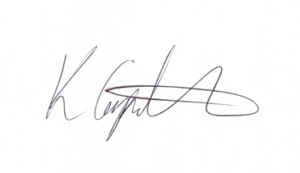
Kim Carpenter
Clerk
 | Governance & Scrutiny Committee
1 | Apologies  To receive any apologies
2 | Declaration of Interest  To receive any declarations of interest
3 | Minutes of the last meeting  To agree the minutes of the meeting held on 21st May 2024
4 | Scrutiny & Review of Council Policies & Procedures  To review and approve the following policies for Full Council resolution at the July Parish Council Meeting:  - Document Retention Policy  - Publication Scheme  - CCTV Policy  - School Award Scheme  - WDPC Training & Development Policy  - Cllr Induction Guide  - Subject Access Request Letter  New Policies  - Acceptable Email use Policy  - Dignity at Work Policy  - Performance Management Policy
5 | Date of the Next Meeting  The next meeting is scheduled for Tuesday 17th September 2024 at 11am.

