To Members of Governance & Scrutiny Committee
Dear Councillor and Committee Member

I summon all members to attend a meeting of the Governance & Scrutiny Committee to be held on Tuesday 21st May 2024 at 11am in the West Dean Centre
Yours sincerely
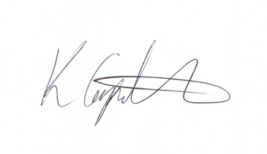
Kim Carpenter
Clerk
 | Governance & Scrutiny Committee
1 | Apologies  To receive any apologies
2 | Declaration of Interest  To receive any declarations of interest
3 | Minutes of the last meeting  To agree the minutes of the meeting held on 16th January 2023
4 | Scrutiny & Review of Council Policies & Procedures  To review and approve the following policies for Full Council resolution at the May Annual Parish Council Meeting:  - Terms of Reference for all Committee’s  - Financial Regulations  - Standing Orders  - Code of Conduct  - Committee to discuss relevant concerns  - Complaints Policy & Procedure  - Data Protection Policy  - Community Engagement & Communication Policy  - Disciplinary Policy  - Equality & Diversity Policy  - Health & Safety  - Whistleblowing  - Grievance Policy & Procedure  - Scheme of Delegation
5 | Date of the Next Meeting  The next meeting is scheduled for Tuesday 16th July 2024 at 11am.

