Annual Report to Parish Councils for County Councilor of Blakeney and Bream Division.

Here is a snap shot of what the last year has brought as the County Councillor for Blakeney and Bream Division, (includes the villages of Blakeney, Newnham, Littledean, Soudley, Viney Hill, Oldcroft, Yorkley, Pillowell, Parkend, Whitecroft and Bream as well as all the forest, hamlets, and farms and roads in between.)

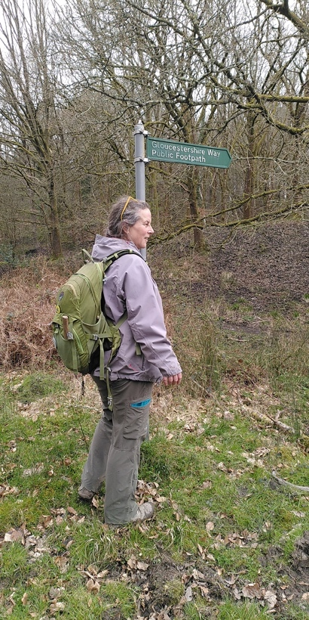
Often it is the Roads that are the most visible part of the role. I meet regularly with the Local Highways Manager; we drive around the division together about every other month as well as being in regular e mail contact. Together we work out solutions to issues that are not straight forward and discuss the allocation of the 30K that councillors have discretion over. For example, Parkend Road, between Bream and Parkend was a real mess, particularly at either end. The inspections had not picked this up so by driving it together and flagging it to him it was pushed up the list and added to the extra resurfacing program that became available across the county.
The Highways Local fund has gone on things like extra hedge cutting to push the hedges back in the winter in the hope that next year’s growth intrudes less onto narrow lanes. Extra drain cleaning, pavement clearing and repair, brighter light bulbs in crossings and 10k being put into work on our extensive network of public footpaths, upgrading and repairing styles, bridges and walls and signage. There is also money being put aside so that there will be funds for a TRO that will reduce the speed limit over the brow of the hill on the A48 at the Viney Hill junction.
I have walked several public footpaths, inspecting works done helping do some clearing and improving signage along the river side path from Bullo Pill, around Awre to Purton (well worth a walk, it is stunning) and the Gloucestershire Way between Speech House and Bream. It was this year that the Commons and Rights of Way Committee put a new footpath on the definitive map along the river between Newnham and Broadoak.

My work representing you at GCC has largely focused on Children and Families. As one of four in our group we have divided the committees between us. All the children and family representation has come to me which includes six different meetings, meaning about a day a week over the year including all the reading. As part of making sure I scrutinize well and hold officers to account I also get involved in various community organizations including volunteering at Blakeney Youth Club, Mentoring for Breath that is based in Bream and teaching Gardening in Bream Primary School. I know that Home to School Transport is a real issue for families and for the funding for the council for example that this is a real live issue that affects many in this mainly rural division.

Transport is another concern for all of us. I take the bus and cycle as much as possible and know that we are all reliant on our cars more than we would like to be. I have been working to get the route between Lydney, via Blakeney and Soudley to Cinderford reinstated, it is still to happen, but I am assured that it will happen before too long! Road Safety is another area I have focused on, attending the Forest of Dean Road Safety Liaison Committee. I am proud that I have been able to make sure that the speed of cars through the statutory Forest has been put on the agenda and kept there by me, I know that these things take time but I will be maintaining the focus on that while I can and hope that it bears fruit by bringing us into line with other areas around the country that have wild animals roaming along the roads.

I have proposed and the following at full council: a review of the catering policy for GCC to support our local farmers by using more local food in their offer as well as continuing to work with the Rural Estates Task Group that have given 9 recommendations to Cabinet for the review of the County Farm Strategy review.

Throughout the year I have sent monthly reports about what GCC is trying to communicate to us all and issues that affect us particularly to all five of the Parish Councils and have attended most of them, as well as being an actual Parish Councillor for Awre.

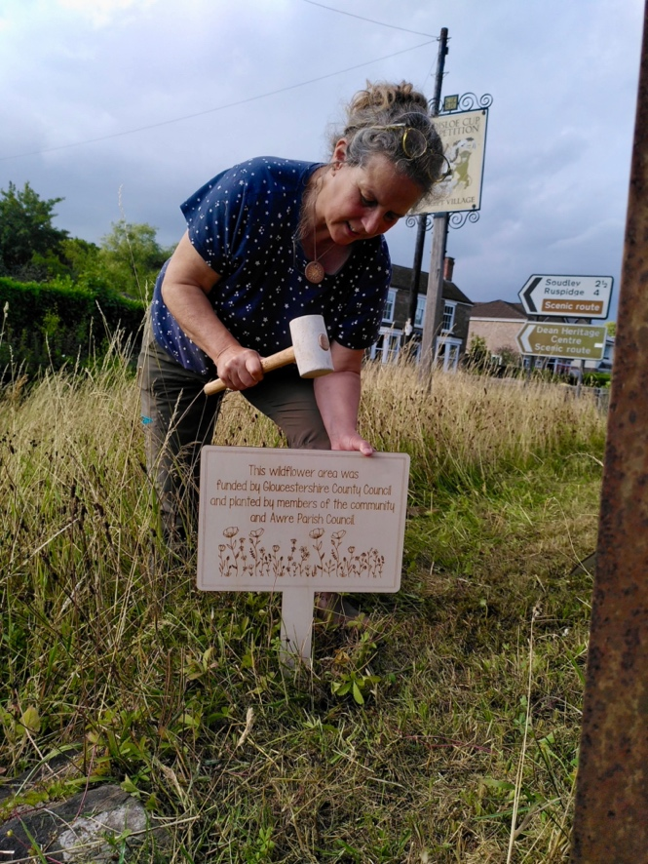
As a councillor we are allocated some funding that is part of the Build Back Better fund. With this money I have supported the Dean Heritage Centre to compost their food waste on site and use it to grow their own veg for the café. I have supported Soudley Primary School to refurbish an outdoor area for SEND children, the Forest of Dean Girl Guides, Music Works and Soudley Village Hall and Blakeney Youth Club.

I have been contacted by many constituents and always try to address their concerns ranging from adult social care to school transport and use of and issues around highways and footpaths and of course the ongoing road closures and potholes that affect us all.

I look forward to continuing as your County Councillor over the next year and please do get in touch if there is something that I can help with or if I am missing something from my monthly reports that would be useful.

Cllr Beki Hoyland.
Beki.hoyland@gloucsetershire.gov.uk
07815660013

