
To, Members of West Dean Parish Council
WEST DEAN PARISH COUNCIL

Kim Carpenter Phil Holland
Clerk to the Council Deputy Clerk
Tel. Parish Office: 01594 564484 (9.00am – 4.00pm)
Email: clerk@westdeanpc.org.uk
Web site: www.westdeanpc.org.uk

Parish Office
West Dean Centre
High Street
Bream
Glos.
GL15 6JW

COUNCIL AGENDA

Dear Councillor

I summon all members to attend a meeting of West Dean Parish Council to be held on Wednesday 24th April 2024 at 7pm in the Witherby Room of the West Dean Centre for the purpose of transacting the business on the agenda as set out below.
Google Maps - The West Dean Centre, High St, Bream, Lydney GL15 6JW

Members are reminded that the Council has a general duty to consider the following matters in the exercise of any of its functions: Equal Opportunities, Crime & Disorder, Health & Safety and Human Rights plus Social, Economic and Environmental matters.

The Council Meeting will follow the Public Forum, which will begin at 7.00pm.

IN ACCORDANCE WITH THE COUNCIL’S CLIMATE EMERGENCY POLICY, PLEASE DO NOT BRING SINGLE USE BOTTLES TO THIS MEETING
Yours sincerely
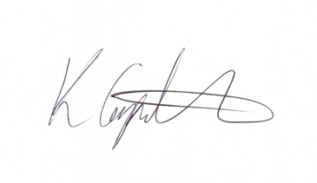
Kim Carpenter
Parish Clerk/RFO

PUBLIC QUESTIONS & COMMENTS – 7.00 pm to 7.30 pm

24041 | Council Formal Business
24041.1 | Apologies  To receive, and consider for approval, any apologies for absence and reasons given.
24041.2 | Declarations of Interest  To receive any declarations of interest, members are reminded to declare any interest on any item on this agenda at this point or at any point during the meeting in accordance with the Council’s Code of Conduct.  A request for dispensations can be requested at the meeting and the paperwork completed for Councils consideration.  To note the dispensations granted to Cllr J Richmond and Cllr S Yeates in respect of Berry Hill Memorial Institute (The Hut).
24041.3 | Minutes of the Previous Meeting  To confirm and sign the minutes of the meeting held the 27th March 2024  Attachment – Minutes of the Council meeting held on 27th March 2024
24042 | Items for Consideration and Resolution
24042.1  24042.1i  24042.1ii  24042.1iii  24042.1iv  24042.1v  24042.2  24042.3 | Finance and Staffing  To review and approve the March 2024 expenditure payment schedule, Direct Debits, Standing Orders, and credit card transactions totalling WDPC = £ 28,042.44 excluding VAT and WDC = £ excluding VAT. (The WDPC payments will also include the Community Infrastructure Grant to the West Dean Centre)  Attachment – 2.1i Expenditure payment schedule  To advise Council that Cllrs Costley & Grant are to authorise payments on the banking system and that Cllrs Moore & Freshwater will be undertaking the financial inspection of April transactions.  To receive a report on the March financial inspection from Cllrs Grant & Evans  To receive the budget monitoring information for WDPC and WDC.  Attachments 2.1v – Working Budgets 2022/23 WDPC & WDC & Budget overview documents.  To review and approve the annual accounts statements for WDPC and the WDC.  To formally review and approve the Zurich insurance policy and quotation and agree that the insurance cover is fit for purpose for the term specified.  To review the WDPC & WDC asset register.
24042.2 | Chestnut Wood Playing Field (Five Acres)  To approve the Agreement for Lease of the Chestnut Wood Playing Field with Forest Dean District Council.  Council to authorise the Clerk to sign agreement and submit to W Jackson, Regeneration Manager, FoDDC.
24043 | Items for Information – Councillors to note.
24043.1 | Planning Committee  To receive and note the minutes of the Planning Committee held on Tuesday 2nd & 16th April 2024  Attachment – Minutes of the meeting held on 2nd & 16th April 2024.
24043.2 | Highways & Footpaths  To approve the minutes of the meeting held on Tuesday 16th April 2024.  Attachment 2.3: Minutes of Highways & footpath Committee held on 16th April 2024.
24043.3 | Chairs Items  To receive any reports or information from the Chair.
24043.4 | Clerks Report  To note deputy clerk’s report and agree recommendations made in the report.  To note that this year marks the 50th Anniversary of West Dean Parish Council being created 1st April 1974 as a civil parish; it was created by the Local Government Act 1972 which reshaped local government.  How would Council like to mark this anniversary?
24043.5 | Public Round-up – 10 minutes  A time set aside for any members of the public to comment or ask further questions following the meeting.
24044 | Forthcoming Meeting Schedule:
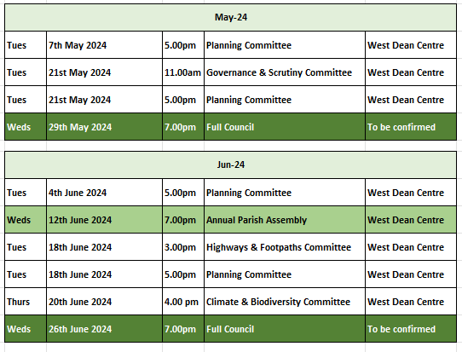
1 The Public Questions & Comments is designed to give electors the opportunity to make representations to the Council or to ask questions. It takes place before the formal meeting of the Council.
2 The time allocated to the whole period of the open forum is 30 minutes.
3 Whether your attendance is part of a deputation or as an individual, the spokesperson will be invited to put the case with a maximum time limit of 10 minutes. Follow up speakers will be allowed 5 minutes in total.
4 The Chairman will decide whether he/she can advise the deputation immediately or if he needs to sound out members and/or consult the Clerk. The Chair will then inform the deputation what action the Parish Council intends to take.
5 The initial response by the Council will be to establish if the matter is something which the Council should be involved in as a matter of public interest or is a private matter for the electors to deal with themselves.
6 What the Council may not be able to do at this initial stage is to attempt to solve the actual problem itself. What the Council will do is to decide the best method to deal with the problem and this can take several forms as follows –
The Council can decide -
(i) The degree to which the Council can act as advocate on behalf of the individual or group of electors.
(ii) To refer the matter to a Committee of the Council for action.
(iii) To place the matter on a future Parish Council agenda.
(iv) To instruct the Clerk to make further enquiries or conduct correspondence on behalf of the deputation or arrange meetings as considered necessary.
(v) If the matter is already on the Council agenda the Chair will invite electors to make any points they feel are relevant regarding the agenda item. The deputation can then remain and listen to the debate in Council.
(vi) If, during the formal meeting, the Chair feels that the deputation has information which will be useful to the Council, the Chair with the agreement of members can invite a spokesperson to address the Council.

