
To, Members of West Dean Parish Council
WEST DEAN PARISH COUNCIL

Kim Carpenter Phil Holland
Clerk to the Council Deputy Clerk
Tel. Parish Office: 01594 564484 (9.00am – 4.00pm)
Email: clerk@westdeanpc.org.uk
Web site: www.westdeanpc.org.uk

Parish Office
West Dean Centre
High Street
Bream
Glos.
GL15 6JW

COUNCIL AGENDA

Dear Councillor

I summon all members to attend a meeting of West Dean Parish Council to be held on Wednesday 28th February 2024 at 7pm in the Witherby Room of the West Dean Centre for the purpose of transacting the business on the agenda set out below.
Google Maps - The West Dean Centre, High St, Bream, Lydney GL15 6JW

The meeting will follow the Public Forum, which will begin at 7.00pm.
IN ACCORDANCE WITH THE COUNCIL’S CLIMATE EMERGENCY POLICY, PLEASE DO NOT BRING SINGLE USE BOTTLES TO THIS MEETING
Yours sincerely
Parish Clerk/RFO
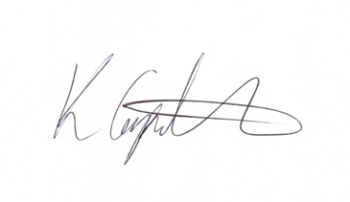
Kim Carpenter

PUBLIC QUESTIONS & COMMENTS – 7.00 pm to 7.30 pm

24021 | Council Formal Business
24011.1 | Co-option of Councillor  To receive the application from Anne Betenson to become a parish councillor for the Bream Ward.  Attachment - Application form for the role of parish councillor completed by Anne Betenson in Agenda Pack.
24021.2 | Apologies  To receive, and consider for approval, any apologies for absence and reasons given.
24021.3 | Declarations of Interest  To receive any declarations of interest, members are reminded to declare any interest on any item on this agenda at this point or at any point during the meeting in accordance with the Council’s Code of Conduct.  A request for dispensations can be requested at the meeting and the paperwork completed for Councils consideration.
24021.4 | Minutes of the Previous Meeting  To confirm and sign the minutes of the meeting held the 31st January 2024  Attachment – Minutes of the Council meeting held on 31st January 2024
24022 | Items for Consideration and Resolution
24022.1  24022.1i  24022.1ii  24022.1iii  24022.1iv | Finance and Staffing  To review and approve the November 2023 expenditure payment schedule, Direct Debits, Standing Orders, and credit card transactions totalling WDPC = £12,006.93 exc. VAT ( £700.80 included but already approved and paid for laptop & data transfer) and WDC = £19,234.53exc. VAT (this includes the £18,069.00 paid for Solar Energy Project at WDC)  Attachment – 2.1i Expenditure payment schedule  To advise Council that Cllrs Bruce & Grant are to authorise payments on the banking system and that Cllrs Francis & Bruce will be undertaking the financial inspection of February transactions.  To receive a report on the January financial inspection from Cllrs Francis & Yeates.  To receive the budget monitoring information for WDPC and WDC.  Attachments 2.1v – Working Budgets 2022/23 WDPC & WDC & Budget overview documents.
24022.2 | Portrait of the King  Council to discuss and decide if we should apply to the Department of Levelling Up and Communities for a free portrait of King Charles. This needs to be ordered before 28th March 2024.
24022.3 | Mobile CCTV  The FODDC Community Support Officer has asked for Council to consider the ownership, ongoing maintenance and moving of a mobile CCTV unit for the parish.  The mobile CCTV would be purchased using the Safer Streets 5 funding and FODDC have added that they may be able to fund some of the costs of removal and re-fitting when it’s moved around the area after its initial installation at Yorkley CC covering the skate park.
24022.4 | Climate & Biodiversity Committee  To receive and approve the minutes of the Climate & Biodiversity Committee held on Thursday 15th February 2024.  To approve the Biodiversity Policy as recommended by the Climate & Biodiversity Committee.  Attachment – Biodiversity Policy & Action Plan
24022.5 | West Dean Centre Management Committee  To receive and note the minutes of the West Dean Centre Management Committee held on Wednesday 21st February 2024.  Attachment – West Dean Management Committee  To approve the following recommendation of the Committee:  That a letter is sent to Bream Primary School clarifying the end of the agreed parking arrangements at the end of March 2024. If there is a need for this arrangement to continue beyond this date that staff wishing to park all day at the Centre will need to apply and a charge for parking will be levied.
24023 | Items for Information – Councillors to note.
24023.1 | Planning Committee  To receive and note the minutes of the Planning Committee held on Tuesday 16th January 2024.  Attachment – Minutes of the meeting held on 16th January 2024
24023.2 | Highways & Footpaths Committee  To receive and note the minutes of the Highways & Footpath Committee held on Tuesday 20th February 2024.  Attachment – Minutes of the meeting held on 20th February 2024
24023.3 | Cannop Ponds  Council to note the recent press release from Forestry England about Cannop Ponds and the further detailed design work which is to be undertaken.
24023.4 | Chairs Items  To receive any reports or information from the Chair.
24023.5 | Clerks Report  To receive the Deputy Clerks report and recommendation on the annual play area inspections.  To receive an update on the FODDC Rural England Community Infrastructure Capital Grant scheme and the progress of the Energy Efficiency Improvement project for the West Dean Centre , this will also include the next steps for the project.
24023.6 | Public Round-up – 10 minutes  A time set aside for any members of the public to comment or ask further questions following the meeting.
24024 | Forthcoming Meeting Schedule:
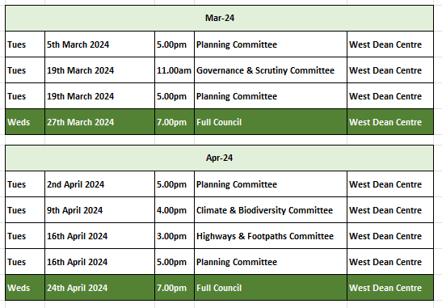
1 The Public Questions & Comments is designed to give electors the opportunity to make representations to the Council or to ask questions. It takes place before the formal meeting of the Council.
2 The time allocated to the whole period of the open forum is 30 minutes.
3 Whether your attendance is part of a deputation or as an individual, the spokesperson will be invited to put the case with a maximum time limit of 10 minutes. Follow up speakers will be allowed 5 minutes in total.
4 The Chairman will decide whether he/she can advise the deputation immediately or if he needs to sound out members and/or consult the Clerk. The Chair will then inform the deputation what action the Parish Council intends to take.
5 The initial response by the Council will be to establish if the matter is something which the Council should be involved in as a matter of public interest or is a private matter for the electors to deal with themselves.
6 What the Council may not be able to do at this initial stage is to attempt to solve the actual problem itself. What the Council will do is to decide the best method to deal with the problem and this can take several forms as follows –
The Council can decide -
(i) The degree to which the Council can act as advocate on behalf of the individual or group of electors.
(ii) To refer the matter to a Committee of the Council for action.
(iii) To place the matter on a future Parish Council agenda.
(iv) To instruct the Clerk to make further enquiries or conduct correspondence on behalf of the deputation or arrange meetings as considered necessary.
(v) If the matter is already on the Council agenda the Chair will invite electors to make any points they feel are relevant regarding the agenda item. The deputation can then remain and listen to the debate in Council.
(vi) If, during the formal meeting, the Chair feels that the deputation has information which will be useful to the Council, the Chair with the agreement of members can invite a spokesperson to address the Council.

