To Members of Governance & Scrutiny Committee
Dear Councillor and Committee Member

I summon all members to attend a meeting of the Governance & Scrutiny Committee to be held on Tuesday 16th January 2024 at 11am in the West Dean Centre
Yours sincerely
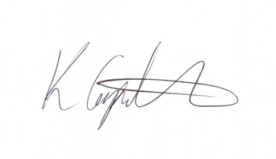
Kim Carpenter
Clerk
 | Governance & Scrutiny Committee
1 | Apologies  To receive any apologies
2 | Declaration of Interest  To receive any declarations of interest
3 | Minutes of the last meeting  To agree the minutes of the meeting held on 21st November 2023
4 | Scrutiny & Review of Council Policies & Procedures  - Full Council – process  Attached document which precise the legal elements of Standing Orders.  - Clerks Pay Scale – In-camera item.  Attached document which details previous and current pay scale and recommendation from GAPTC.  - West Dean Centre  Progress report  - Biodiversity Policy  A model policy has been produced, should this be adopted by WDPC?
Date of the Next Meeting

The next meeting is scheduled for Tuesday 19th March 2024 at 11am.

