To Members of Finance & Staffing Committee

Dear Councillor and Committee Member

I summon all members to attend a meeting of the Finance & Staffing Committee to be held on Friday 20th October at 9am in the Witherby Room of the West Dean Centre

Yours sincerely
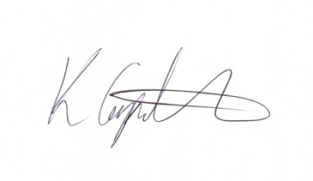
Kim Carpenter
Clerk

 | Finance & Staffing Committee
1 | Apologies  To receive any apologies for absence.
2 | Declaration of Interest  To receive any declarations of interest from Councillor’s.
3 | Minutes of the last meeting  To review and approve the minutes of the previous meeting.
4 | Budget Monitoring  Setting of timelines for budget meetings and approval process.
5 | Grant Awards  Review of the 16 applications for funding and decision about the monies to be awarded. A Dropbox link to the applications was sent to Council for review.
6 | Staff Appraisals  Setting the timeline for appraisals
7 | Date of the Next Meeting  To be confirmed?

