
WEST DEAN PARISH COUNCIL

Kim Carpenter Phil Holland
Clerk to the Council Deputy Clerk
Tel. Parish Office: 01594 564484 (9.00am – 4.00pm)
Email: clerk@westdeanpc.org.uk
Web site: www.westdeanpc.org.uk

Parish Office
West Dean Centre
High Street
Bream
Glos.
GL15 6JW

COUNCIL AGENDA

To, Members of West Dean Parish Council

Dear Councillor

I summon all members to attend a meeting of West Dean Parish Council to be held on Wednesday 27th September 2023 at 7pm in the Witherby Room of the West Dean Centre for the purpose of transacting the business on the agenda set out below.

Google Maps - The West Dean Centre, High St, Bream, Lydney GL15 6JW

What3Words Location - ///thrillers.tweezers.lots

The meeting will follow the Public Forum, which will begin at 7.00pm.

IN ACCORDANCE WITH THE COUNCIL’S CLIMATE EMERGENCY POLICY, PLEASE DO NOT BRING SINGLE USE BOTTLES TO THIS MEETING
Yours sincerely
Parish Clerk/RFO
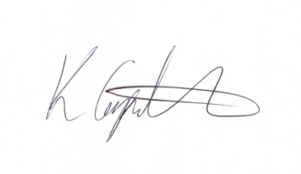
Kim Carpenter

PUBLIC QUESTIONS & COMMENTS – 7.00 pm to 7.30 pm
23091 | Council Formal Business
23091.1 | Apologies  To receive, and consider for approval, any apologies for absence and reasons given.
23091.2 | Declarations of Interest  To receive any declarations of interest, members are reminded to declare any interest on any item on this agenda at this point or at any point during the meeting in accordance with the Council’s Code of Conduct.
23091.3 | Minutes of the Previous Meeting  To confirm and sign the minutes of the meeting held the 30th August 2023.  Attachment – Minutes of the Council meeting held on 30th August 2023.
23092 | Items for Consideration and Resolution
23092.1  23092.1i  23092.1ii  23092.1iii  23092.1iv  23092.1v  23092.1vi | Finance and Staffing  To review and approve the September 2023 expenditure payment schedule, Direct Debits, Standing Orders, and credit card transactions totalling WDPC = £14,337.43 exc. VAT and WDC = £1,992.24 exc. VAT  Attachment – 2.1i Expenditure payment schedule  To advice Council that Cllrs Grant and Costley are to authorise payments on the banking system and that Cllrs Wheeler & Lewis will be undertaking the financial inspection of September transactions.  To receive a report from Cllrs Evans & Francis that the August financial inspection including the bank reconciliations have been satisfactorily conducted.  To receive the budget monitoring information for WDPC and WDC.  Attachments 2.1v – Working Budgets 2022/23 WDPC & WDC & Budget overview documents.  The Clerk is recommending that a minimum of £60,000 be kept in the WDPC current account, this is approximately 3-4 months expenditure.  The reason for this is that any movements between the current and savings accounts require Councillor authorisation. To maintain this level of funding within the current account will also require the transfer of money from the savings account into the current account which would be authorised as per the monthly expenditure payments.  There will also be a need to ensure that during the Community Grant awards that sufficient money be transferred to the current account to make the payments, this will be twice yearly in the month preceding the award approval by Council i.e.. September for October award.  To receive and note the conclusion of the PKF Littlejohn external audit of the Annual Governance and Accountability Return (AGAR).
23092.2  23092.2i  23092.2ii  23092.2iii  23092.2iv | Five Acres Project  To confirm the engagement of Harrison Clark Rickerby to act as the Councils solicitor for the lease agreement with Forest of Dean District Council, at an approximate cost of £4,500 plus VAT and disbursements to be re-claimed from FODDC.  To confirm the costs associated with the installation of the access gateways to the Five Acres field and confirm this cost be repaid by FODDC.  To seek permission from Council for investigative works to be undertaken by BAM Construction in preparation for the 3G pitch.  To discuss the rental fee within the lease agreement. A peppercorn rent is not suitable, and Cllr Richmond has proposed that this rent be set at £700 per year with the funds being ringfenced as a primary school sports prize fund, with these awards being named the `Chestnut Wood Awards’.
23092.3 | Governance & Scrutiny Committee  To note and receive the minutes of the Governance & Scrutiny Committee held on Tuesday 19th September.  Attachment – Minutes of the Governance & Scrutiny Committee held on Tuesday 19th September 2023.  To approve the following recommendations from the meeting:  Community Engagement & Communication Policy  That Council approve this policy document.  Berry Hill, Christchurch & Edge End NDP  That Council accept the offer made by Cllr Yeates to undertake a free of charge heritage assessment of the plan area for inclusion in the updated documents.  The clerk will find a suitable person/consultancy to undertake the review and update of the NDP and gather quotations for this work.  It is also recommended that a small working party be created to support and progress this project.  WDC  It is recommended that the Clerk consult GAPTC and any other suitable body to seek advice on the various options which could be used to manage the West Dean Centre.
23092.4 | Climate & Biodiversity  Food Resilience – the committee are seeking approval for a donation of £1,000 to support this event in April 2024.
23092.5 | Acknowledgement of Achievement  To discuss the proposal from a member of public to mark the achievement of Charlie Hatton on becoming the Downhill Mountain Bike World Champion 2023.  Charlie and his family reside in Ellwood, and we have been asked as a Parish Council to place a commemorative plaque or sign at the entrance to the village.
23092.4 | Remembrance Day Parade and Wreaths  The Bream Remembrance Day Service and Parade, which has previously been organised by Steve Crick, this Civic Ceremony needs to be planned and delivered by the Parish Council. Advice has been sought from the British Legion and a project plan is being developed by the Clerk for this year’s event and for future implementation, this plan will be shared with Council and all other parties involved as soon as completed.  There are some key elements within the plan which will require funding to be allocated, this includes the Order of Service, possibly the hire of a PA system, wreaths, and potentially other items for the Remembrance Day event. It is anticipated that the `Tommy Solider’ will also require replacement as will the current decorative knitted poppies, which are placed around the cenotaph.  The budget for this year is approximately £500.
23092.5  23092.5i | Grass Cutting – Additional Works  The grass cutting & maintenance contractor is recommending two additional grass cuts to all areas maintained within the Parish. This request is due to the growing season being influenced by the hot spell followed by significant rainfall.  The cost implications of these three additional cuts are £2,178.00 plus VAT.  The officer’s comment is that we are not in the business of lawn care but maintaining areas suitable for children to play, with longer grass providing some cushioning if they fall over.  We are recommending that Council approve one additional cut for March 2024 of 14 areas within the parish is £726.00 plus VAT.
23093 | Items for Information – Councillors to note.
23093.1 | Planning Committee  To receive and note the minutes of the Planning Committee held on Tuesday 5th and 19th September 2023.  Attachments – Minutes of the meeting held on 5th September 2023 & the minutes of the meeting held on Tuesday 19th September 2023.
23083.2 | Chairs Items  To receive any reports or information from the Chair.
23073.3 | Public Round-up – 10 minutes  A time set aside for any members of the public to comment or ask further questions following the meeting.
23044 | Forthcoming Meeting Schedule:
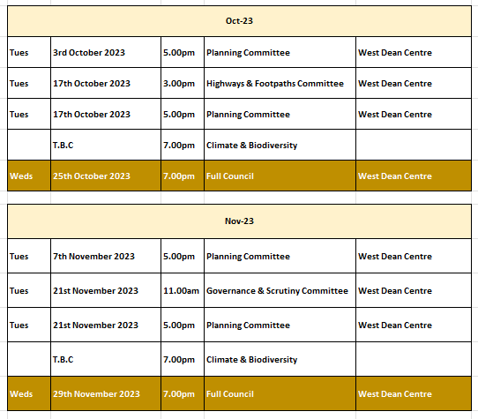
1 The Public Questions & Comments is designed to give electors the opportunity to make representations to the Council or to ask questions. It takes place before the formal meeting of the Council.
2 The time allocated to the whole period of the open forum is 30 minutes.
3 Whether your attendance is part of a deputation or as an individual, the spokesperson will be invited to put the case with a maximum time limit of 10 minutes. Follow up speakers will be allowed 5 minutes in total.
4 The Chairman will decide whether he can advise the deputation immediately or if he needs to sound out members and/or consult the Clerk. The Chairman will then inform the deputation what action the Parish Council intends to take.
5 The initial response by the Council will be to establish if the matter is something which the Council should be involved in as a matter of public interest or is a private matter for the electors to deal with themselves.
6 What the Council may not be able to do at this initial stage is to attempt to solve the actual problem itself. What the Council will do is to decide the best method to deal with the problem and this can take several forms as follows –
The Council can decide -
(i) The degree to which the Council can act as advocate on behalf of the individual or group of electors.
(ii) To refer the matter to a Committee of the Council for action.
(iii) To place the matter on a future Parish Council agenda.
(iv) To instruct the Clerk to make further enquiries or conduct correspondence on behalf of the deputation or arrange meetings as considered necessary.
(v) If the matter is already on the Council agenda the Chairman will invite electors to make any points they feel are relevant regarding the agenda item. The deputation can then remain and listen to the debate in Council.
(vi) If, during the formal meeting, the Chairman feels that the deputation has information which will be useful to the Council, the Chairman with the agreement of members can invite a spokesperson to address the Council.

