
WEST DEAN PARISH COUNCIL

Kim Carpenter Phil Holland
Clerk to the Council Deputy Clerk
Tel. Parish Office: 01594 564484 (9.00am – 4.00pm)
Email: clerk@westdeanpc.org.uk
Web site: www.westdeanpc.org.uk

Parish Office
West Dean Centre
High Street
Bream
Glos.
GL15 6JW

COUNCIL AGENDA

To, Members of West Dean Parish Council

Dear Councillor

I summon all members to attend a meeting of West Dean Parish Council to be held on Wednesday 30th August 2023 at 7pm at Ellwood Football Club, Ellwood for the purpose of transacting the business on the agenda set out below.

Google Maps - Ellwood Football Club - Google Maps
What3Words Location - ///warbler.sides.treetop

The meeting will follow the Public Forum, which will begin at 7.00pm.

IN ACCORDANCE WITH THE COUNCIL’S CLIMATE EMERGENCY POLICY, PLEASE DO NOT BRING SINGLE USE BOTTLES TO THIS MEETING
Yours sincerely
Parish Clerk/RFO
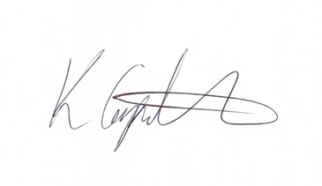
Kim Carpenter

PUBLIC QUESTIONS & COMMENTS – 7.00 pm to 7.30 pm
23081 | Council Formal Business
23081.1 | Apologies  To receive, and consider for approval, any apologies for absence and reasons given.
23081.2 | Declarations of Interest  To receive any declarations of interest, members are reminded to declare any interest on any item on this agenda at this point or at any point during the meeting in accordance with the Council’s Code of Conduct.
23081.3 | Minutes of the Previous Meeting  To confirm and sign the minutes of the meeting held on 26th July 2023  Attachment 1.3 – Minutes of the Council Meeting held on 26th July 2023.
23082 | Items for Consideration and Resolution
23082.1  23082.1i  23082.1ii  23082.1iii  23082.1iv | Finance and Staffing  To review and approve the August 2023 expenditure payment schedule, Direct Debits, Standing Orders, and credit card transactions totalling £11,630.06 exc. VAT.  Attachment – 2.1i Expenditure payment schedule  To confirm the schedule of Councillors for electronic payment authorisation and financial inspections.  To receive a report from Cllrs Evans & Francis that the July financial inspection including the bank reconciliations have been satisfactorily conducted.  To receive the budget monitoring information for WDPC and WDC.  Attachments 2.1v – Working Budgets 2022/23 WDPC & WDC & Budget overview documents.
23082.2 | Introduction of Tourism Tax.  Cllr Dunford proposes the following motion for consideration by Council:  This Council would welcome the introduction of a Local Tourism Tax (set a £1 per night?) levied on all adults who stay in all (registered ?) overnight accommodation within the Forest of Dean District Council area.  The income from this tax is to be ring fenced to support environmental projects, sporting, cultural and leisure facilities, subsidised public transport, and infrastructure projects that would benefit the local communities.  As a Council we will request that District Council work towards such an introduction within an achievable timeframe and will support them in any action needed to implement such a scheme.
23082.3 | Parish Newsletter  To review and discuss the newsletter and agree final the number to be printed for distribution to local shops, pubs, etc.
23082.4 | Highways & Footpaths  To receive the minutes of the Highways & Footpaths Committee meeting held on 15th August 2023.  Attachment 2.4 – Minutes of the Highways & Footpaths Committee held on 15th August 2023.  The recommendations from the Highways & Footpaths Committee for consideration are:  - The installation of two VAS post be requested from GCC Highways for the A4136 at Edge End, both ends of the village and an additional post at Grove Road Berry Hill.  - That seven speed surveys be commissioned with GCC Highways for the locations detailed in the minutes of the meeting.  - That an advert for Snow Wardens in the parish be placed on WDPC website and social media and potentially in the local papers depending on costs. To also ask Councillors if they know of any potential snow wardens or if they would like to be a snow warden.  - That WDPC begin the process of completing the forms to record and recognise the Statutory Forest Perambulation Boundary Walk with Gloucestershire County Council.  - That a review of the Berry Hill NDP is programmed into the Councils work schedule as an urgent matter, as the first review point of 2021 has been missed. This review point was allocated to ensure the NDP’s conformity with FODDC Core Strategy and Local Plan.
23082.5 | Wye Valley ANOB - Position Statement Consultation  Council to prepare a consultation response to the Wye Valley AONB position statements as we are a consultee of this process as part of the parish lies within this designation.  The position statements being consulted on are:  - Housing Development in the Wye Valley AONB and its Setting  - Landscape-Led Development
23083 | Items for Information – Councillors to note.
23083.1 | Planning Committee  To receive and note the minutes of the Planning Committee meetings held on 5th and 15th August 2023.  Attachment 3.1 – Minutes of the Planning Committee held on 5th & 15th August 2023.
23083.2 | Climate & Biodiversity Committee  To receive and note the minutes of the Climate & Biodiversity Committee meeting held on 17th August 2023.  Attachment 3.2 – Minutes of the Climate & Biodiversity Committee held on 17th August 2023.
23083.3 | West Dean Centre Management Committee  To receive and note the minutes of the West Dean Centre Management Committee held on 14th August 2023.  Attachment 3.3 – Minutes of the West Dean Centre Management Committee held on 14th August 2023.
23083.4 | Chairs Items  To receive any reports or information from the Chair.
23073.5 | Clerk’s Reports  To receive any reports or updates on actions or communications from the Clerks.  To discuss and approve any recommendations or requests within the reports.
23073.6 | Public Round-up – 10 minutes  A time set aside for any members of the public to comment or ask further questions following the meeting.
23044 | Forthcoming Meeting Schedule:
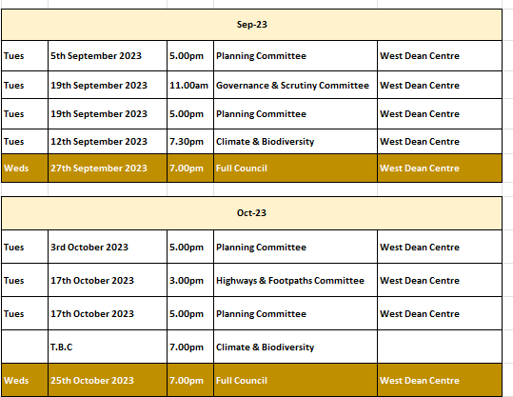
1 The Public Questions & Comments is designed to give electors the opportunity to make representations to the Council or to ask questions. It takes place before the formal meeting of the Council.
2 The time allocated to the whole period of the open forum is 30 minutes.
3 Whether your attendance is part of a deputation or as an individual, the spokesperson will be invited to put the case with a maximum time limit of 10 minutes. Follow up speakers will be allowed 5 minutes in total.
4 The Chairman will decide whether he can advise the deputation immediately or if he needs to sound out members and/or consult the Clerk. The Chairman will then inform the deputation what action the Parish Council intends to take.
5 The initial response by the Council will be to establish if the matter is something which the Council should be involved in as a matter of public interest or is a private matter for the electors to deal with themselves.
6 What the Council may not be able to do at this initial stage is to attempt to solve the actual problem itself. What the Council will do is to decide the best method to deal with the problem and this can take several forms as follows –
The Council can decide -
(i) The degree to which the Council can act as advocate on behalf of the individual or group of electors.
(ii) To refer the matter to a Committee of the Council for action.
(iii) To place the matter on a future Parish Council agenda.
(iv) To instruct the Clerk to make further enquiries or conduct correspondence on behalf of the deputation or arrange meetings as considered necessary.
(v) If the matter is already on the Council agenda the Chairman will invite electors to make any points they feel are relevant regarding the agenda item. The deputation can then remain and listen to the debate in Council.
(vi) If, during the formal meeting, the Chairman feels that the deputation has information which will be useful to the Council, the Chairman with the agreement of members can invite a spokesperson to address the Council.

