To Members of Governance & Scrutiny Committee

Dear Councillor and Committee Member

I summon all members to attend a meeting of the Governance & Scrutiny Committee to be held on Tuesday 21st March at 11am in the West Dean Centre

Yours sincerely
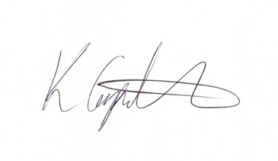
Kim Carpenter
Clerk

 | Governance & Scrutiny Committee
1 | Apologies  To receive any apologies
2 | Declaration of Interest  To receive any declarations of interest
3 | Minutes of the last meeting  To agree the minutes of the meeting held on 17th January 2023
4 | Review of Council Policies & Procedures  To consider the review of the following documents:  - Health & Safety Policy  - Register of Interests  - Complaints Policy & Procedure  - Financial Regulations  - Disciplinary Policy  - NEW - Acceptance of Electronic Communications  - NEW - CCTV Policy
5 | Action Plan  To continue the development of the Council’s Action Plan including a mission statement or strap line.
6 | Date of the Next Meeting  16th May 2023 at 11am in the West Dean Centre

