To Members of Governance & Scrutiny Committee

Dear Councillor and Committee Member

I summon all members to attend a meeting of the Governance & Scrutiny Committee to be held on Tuesday 17th January 2023 at 11am in the West Dean Centre

Yours sincerely
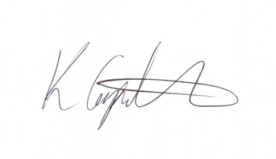
Kim Carpenter
Clerk

 | Governance & Scrutiny Committee
1 | Apologies  To receive any apologies
2 | Declaration of Interest  To receive any declarations of interest
3 | Minutes of the last meeting  To agree the minutes of the meeting held on 15th November 2022.
4 | Review of Council Policies & Procedures  To consider the review of the following documents:  - Code of Conduct – further suggested amendments to section 9a, 9b & 9c  - Standing Orders  - Procurement Policy – Ensuring future reference to The Procurement Bill expected mid-2023.  - Safeguarding Policy  - Whistleblowing Policy
5 | Date of the Next Meeting  21st March 2023 at 11am in the West Dean Centre

