To Members of Governance & Scrutiny Committee

Dear Councillor and Committee Member

I summon all members to attend a meeting of the Governance & Scrutiny Committee to be held on Tuesday 19th July at 11am in the West Dean Centre

Yours sincerely
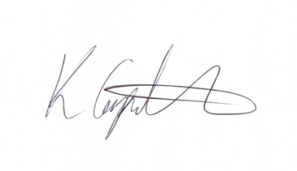
Kim Carpenter
Clerk

 | Governance & Scrutiny Committee
1 | Apologies
2 | Declaration of Interest
3 | Minutes of the last meeting
4 | Review of Council Policies & Procedures  - Updated Financial Regulations – NALC model as recommended by internal audit  - Privacy notice for staff and councillors – recommendation of internal audit  - Grant Award Policy  - Grant Application Form
5 | Council Committees  Review of committees and terms of reference.  - West Dean Centre
6 | Date of the Next Meeting  Tuesday 19th July 2022 at 11am in the West Dean Centre

