To Members of Staffing & Finance Committee

Dear Councillor and Committee Member

I summon all members to attend a meeting of the Staffing & Finance Committee to be held on Wednesday 18th May 2022 at 2:30pm in the West Dean Centre

Yours sincerely
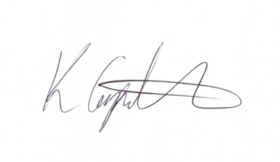
Kim Carpenter
Clerk

 | Finance & Staffing Committee
1 | Apologies
2 | Declaration of Interest
3 | Minutes of the last meeting
4 | Budget Monitoring
5 | Staff Appraisals
6 | Grant Awards  Review of the 13 applications for funding and decision about the monies to be awarded. A Dropbox link to the applications was sent to Council for review early May to allow time for review of all applications and supporting documents.
7 | Date of the Next Meeting

