
WEST DEAN PARISH COUNCIL

Kim Carpenter Phil Holland
Clerk to the Council Deputy Clerk
Tel. Parish Office: 01594 564484 (9.00am – 4.00pm)
Email: clerk@westdeanpc.org.uk
Web site: www.westdeanpc.org.uk

Parish Office
West Dean Centre
High Street
Bream
Glos.
GL15 6JW

COUNCIL AGENDA

To Members of West Dean Parish Council

Dear Councillor

I summon all members to attend a meeting of West Dean Parish Council to be held on Wednesday 30th November 2022, at the West Dean Centre, Bream. The meeting will follow the Public Forum, which will begin at 7.00pm.

IN ACCORDANCE WITH THE COUNCIL’S CLIMATE EMERGENCY POLICY, PLEASE DO NOT BRING SINGLE USE BOTTLES OR CUPS TO THIS MEETING

PLEASE NOTE THAT THIS MEETING MAY BE AUDIO OR VIDEO RECORDED

Yours sincerely
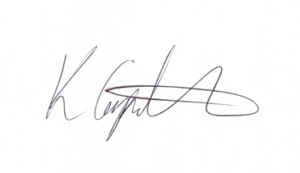
Kim Carpenter
Clerk

PUBLIC FORUM – 7.00 pm to 7.30 pm

22111 | Council Formal Business
2211.1 | Apologies  To receive any apologies for absence
2211.2 | Declarations of Interest  To receive any declarations of interest
2211.3 | Minutes of the Previous Meeting  To confirm and sign the minutes of the meeting held on 26th October 2022.  Attachment 1.3 – Minutes of the Council Meeting held on 26th October 2022.
22112 | Items for Discussion and Decision
22112.1  22112.1i  22112.1ii  22112.1iii  22112.1iv  22112.1v  22112.1vi  22112.1vii  22112.1viii  22112.1ix | Finance and Staffing  To receive reports and updates on the Councils’ financial standing:  For Council to note and ratify that the Local Government pay agreement has been reached, this gives all staff on NJC pay scales a £1925 award on their pay scale point back dated to April 2022. The pay agreement also gives all NJC pay scale staff an additional day’s annual leave from 1st April 2023.  To agree for the office staff to carry forward 5 days annual leave from the 2022/23 year into the 2023/24 year. To agree the carryover of 25hrs for the WDC cleaner from 2022/23 into 203/24 for a house move.  To note the completion of the CiLCA qualification by the Clerk and to note the contractual one scale point increment that is awarded upon obtaining this qualification.  To agree the November 2022 payment schedule, Direct Debits and credit card transactions totalling £19,146.23 (please note Autumn Grant awards, as agreed in October were processed from bank early November) – Attachment 2.1iii November payment schedule, with legislation detailed which allows the parish to spend.  To appoint two Councillors as signatories for November 2022 electronic payments.  To receive a report from Councillors Bruce and Richmond that the October 2022 financial inspections have been satisfactorily conducted.  To appoint two Councillors to conduct the November 2022 financial inspections.  To receive the budget monitoring information for WDPC and WDC. Attachments 2.1viii – Working Budgets 2022/23 WDPC & WDC & Budget overview document  Council to consider the engagement of a solicitor to pursue the complaint against the previous accountancy firm for the errors made and consider the potential costs of this course of action balanced against potential awarded costs.  Attachment 2.1viiii –
22112.2  22112.2i  22112.2ii  22112.2iii | Governance & Scrutiny  To receive the minutes of the meeting held on 15th November 2022. Attachment 2.2i – Minutes of the Governance & Scrutiny Meeting held on 15th November 2022  To agree and approve the following documents reviewed at the meeting:  - Data Protection Policy  - Equalities & Diversity Policy  - Disciplinary Policy  - Communications Policy  - Grievance Policy.  To agree and approve Cllrs S Dunford’s suggestion for an amendment to the Code of Conduct. Attachment – 2.2iii Code of Conduct with amended clauses.
22112.3 | WDPC Newsletter  To consider and agree the name for the newsletter and the number of printed copies to be produced alongside the issues an electronic issue. To also discuss the writing and production of articles for the newsletter.
22112.4  22112.4i  22112.4ii | WDC Gates  For Council to consider the quotation for the repair or alternative option for the gates to the Centre, this is due to ongoing vandalism of the motorised arms that control the gates.  There is also an option within the quotation to move the fence to enclose the back of the youth shelter, thus making it accessible only from the pavement.  Attachment – GDR Gates Quotation
22112.5 | Warm Space  The recent application to `Warm this Winter’ sub-grant has been unsuccessful.  Council to consider alternative funding avenues potentially from FODDC or use of its own grant awards to support the work being done in the community and to prevent duplication of effort in applying for funding.
22112.6 | Preparatory Work for Bream NDP  Cllr S Yeates asks Council to consider commissioning a heritage report for Bream High Street and surroundings, in preparation for the Bream neighbourhood development plan. This is potentially an important piece of preparatory work considering the proposed District Council’s Local Plan housing allocations.
22113 | Items for Information – Councillors to note
22113.1 | Planning Committee  To receive and note the minutes of the Planning Committee meetings held on 1st & 15th November 2022.  Attachments 3.1 – Planning minutes for 1st & 15th November 2022.
22113.2 | Climate and Biodiversity Committee  To receive and note the minutes of the Climate & Biodiversity Committee held on 10th November 2022.  Attachment 3.2 – Climate & Biodiversity minutes from 10th November 2022.
22113.3 | Chairs Items  To receive any reports or information from the Chair.
22113.4 | Public Round-up – 10 minutes  A time set aside for any members of the public to comment or ask further questions following the meeting
22044 | Forthcoming Meetings:
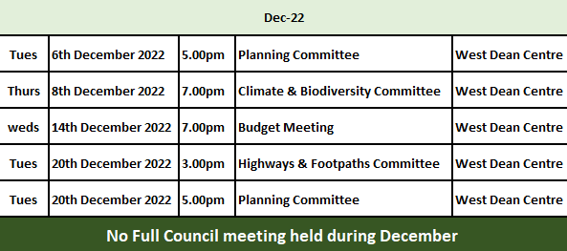

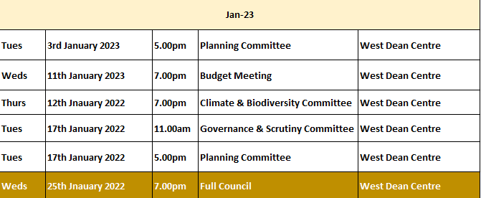

1 The Public Open Forum is designed to give electors the opportunity to make representations to the Council or to ask questions. It takes place before the formal meeting of the Council.
2 The time allocated to the whole period of the open forum is 30 minutes.
3 Whether your attendance is part of a deputation or as an individual, the spokesperson will be invited to put the case with a maximum time limit of 10 minutes. Follow up speakers will be allowed 5 minutes in total.
4 The Chairman will decide whether he can advise the deputation immediately or if he needs to sound out members and/or consult the Clerk. The Chairman will then inform the deputation what action the Parish Council intends to take.
5 The initial response by the Council will be to establish if the matter is something which the Council should be involved in as a matter of public interest or is a private matter for the electors to deal with themselves.
6 What the Council may not be able to do at this initial stage is to attempt to solve the actual problem itself. What the Council will do is to decide the best method to deal with the problem and this can take several forms as follows –
The Council can decide -
(i) The degree to which the Council can act as advocate on behalf of the individual or group of electors.
(ii) To refer the matter to a Committee of the Council for action.
(iii) To place the matter on a future Parish Council agenda.
(iv) To instruct the Clerk to make further enquiries or conduct correspondence on behalf of the deputation or arrange meetings as considered necessary.
(v) If the matter is already on the Council agenda the Chairman will invite electors to make any points they feel are relevant regarding the agenda item. The deputation can then remain and listen to the debate in Council
(vi) If, during the formal meeting, the Chairman feels that the deputation has information which will be useful to the Council, the Chairman with the agreement of members can invite a spokesperson to address the Council.

