To Members of Governance & Scrutiny Committee

Dear Councillor and Committee Member

I summon all members to attend a meeting of the Governance & Scrutiny Committee to be held on Tuesday 27th September at 11am in the West Dean Centre

Yours sincerely
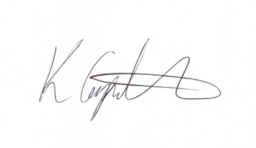
Kim Carpenter
Clerk

 | Governance & Scrutiny Committee
1 | Apologies  To receive any apologies
2 | Declaration of Interest  To receive any declarations of interest
3 | Minutes of the last meeting  To agree the minutes of the meeting held on Tuesday 19th July 2022.
4 | Review of Council Policies & Procedures  - Training & Development Policy  - Publication Scheme  - Initial development of action plan and mission statement  To agree the documents for review at the November meeting.
5 | Date of the Next Meeting  Tuesday 15th November at 11am in the West Dean Centre

